**Localization :**

In android, **Localization** is a process to change the string into multiple languages based on our requirements.

Android is the most popular mobile operating system and it runs on millions of devices in many regions. So if we implement an android app which is localized for all the regions, then it will reach the most of users.

While implementing localization in our android app, we need to handle text, audio files, numbers, currency and graphics in a way that is appropriate for the locales where our application is used.

Here we are going to build an application that supports localization of strings in multiple languages, such as **Telugu**, **Hindi,** and **Japanese**.

**Android Localization of Strings**

Generally, android consider **English** is a default language and it loads the string resources from **/res/values/strings.xml**. In case, if we want to add a support for other languages, we need to create a **values** folder by appending the Hyphen and ISO language code.

For example, if we want to add support for **Japanese**, then we need to create a **values** folder named **values-ja** under the **res** folder and add a **strings.xml** file in it with all the strings that need to translate into the **Japanese** Language.

Following is the example of defining a multiple **values** folder in **/res** directory to support localization of strings in multiple languages such as Telugu, Hindi and Japanese.

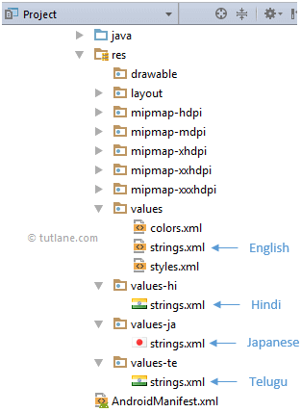

Once we create required files and change the device language through **Settings** à **Language & Input** à Select **Language** (**Japanese**), android OS will check for the appropriate language resources available in the app.

In case, if the app supports a selected language, then android will look for the string resources in **values-(ISO language code)** folder of the project. For example, the selected language is **Japanese**, then it will load the string values from a **values-ja/strings.xml** file.

If any string value missing from supported language (**strings.xml**) file, then android will load the missing strings from default **strings.xml** file i.e. **values/strings.xml**.

While implementing an android app that supports multiple languages, always consider loading the string values from **strings.xml** file otherwise the language-translation will become difficult.

Now we will see how to create an application that supports a localization of strings in multiple languages, such as Telugu, Hindi and Japanese in android with example

Android Localization Example

Following is the example of building an app that supports a localization of strings in multiple languages in android.

Create a new android application using android studio and give names as **LocalizationExample**. In case if you are not aware of creating an app in android studio check this article [Android Hello World App](https://www.tutlane.com/tutorial/android/android-hello-world-app-example).

Now open **activity_main.xml** file from **\res\layout** folder path and write the code like as shown below.

activity_main.xml

<?xml version="1.0" encoding="utf-8"?>  
<LinearLayout xmlns:android="http://schemas.android.com/apk/res/android"  
    android:orientation="vertical" android:layout_width="match_parent"  
    android:layout_height="match_parent">  
    <TextView  
        android:id="@+id/textview1"  
        android:layout_width="wrap_content"  
        android:layout_height="wrap_content"  
        android:layout_marginTop="100dp"  
        android:layout_gravity="center"  
        android:textColor="#F1511B"  
        android:textSize="30dp"  
        android:textStyle="bold"  
        android:text="@string/hello"/>  
    <TextView  
        android:id="@+id/textview2"  
        android:layout_width="wrap_content"  
        android:layout_height="wrap_content"  
        android:layout_marginTop="30dp"  
        android:layout_gravity="center"  
        android:textColor="#80CC28"  
        android:textSize="30dp"  
        android:textStyle="bold"  
        android:text="@string/tutlane"/>  
    <TextView  
        android:id="@+id/textview3"  
        android:layout_width="wrap_content"  
        android:layout_height="wrap_content"  
        android:layout_marginTop="30dp"  
        android:layout_gravity="center"  
        android:textColor="#80CC28"  
        android:textSize="30dp"  
        android:textStyle="bold"  
        android:text="@string/android"/>  
    <TextView  
        android:id="@+id/textview4"  
        android:layout_width="wrap_content"  
        android:layout_height="wrap_content"  
        android:layout_marginTop="20dp"  
        android:layout_gravity="center"  
        android:textSize="30dp"  
        android:textStyle="bold"  
        android:text="@string/reigster"/>  
</LinearLayout>

Now open your **strings.xml** that is located under **\res\values** path and write the code like as shown below.

values/strings.xml

<resources>  
    <string name="app_name">Localization Example</string>  
    <string name="hello">Hello World</string>  
    <string name="tutlane">Tutlane</string>  
    <string name="android">Android Tutorial</string>  
    <string name="reigster">Register</string>  
</resources>

As discussed, we are building an app to support multiple languages, such as **Telugu**, **Hindi** and **Japanese** so we need to create **values-te**, **values-hi** and **values-ja** folders under **res** folder and add **strings.xml** file in each folder like as shown below.



Now open **strings.xml** file from each folder and write the code like as shown below.

values-hi/strings.xml

<?xml version="1.0" encoding="utf-8"?>  
<resources>  
    <string name="app_name">स्थानीयकरणउदाहरण</string>  
    <string name="hello">नमस्तेदुनिया</string>  
    <string name="tutlane">ट्यूटोरियलगली</string>  
    <string name="android">एंड्रॉयडट्यूटोरियल</string>  
    <string name="reigster">रजिस्टर</string>  
</resources>

values-te/strings.xml

<?xml version="1.0" encoding="utf-8"?>  
<resources>  
    <string name="app_name">స్థానికీకరణఉదాహరణ</string>  
    <string name="hello">హలోవరల్డ్</string>  
    <string name="tutlane">ట్యుటోరియల్వీధి</string>  
    <string name="android">ఆండ్రాయిడ్ట్యుటోరియల్</string>  
    <string name="reigster">నమోదు</string>  
</resources>

values-ja/strings.xml

<?xml version="1.0" encoding="utf-8"?>  
<resources>  
    <string name="app_name">ローカリゼーション例</string>  
    <string name="hello">こんにちは世界</string>  
    <string name="tutlane">ツタン</string>  
    <string name="android">アンドロイドチュートリアル</string>  
    <string name="reigster">登録</string>  
</resources>

Now open your main activity file **MainActivity.java** from **\java\com.tutlane.localizationexample** path and write the code like as shown below

MainActivity.java

package com.tutlane.localizationexample;  
import android.support.v7.app.AppCompatActivity;  
import android.os.Bundle;  
public class MainActivity extends AppCompatActivity {  
    @Override  
    protected void onCreate(Bundle savedInstanceState) {  
        super.onCreate(savedInstanceState);  
        setContentView(R.layout.activity_main);  
    }  
}

## Output of Android Localization Example

When we run above program in android studio we will get the result like as shown below.

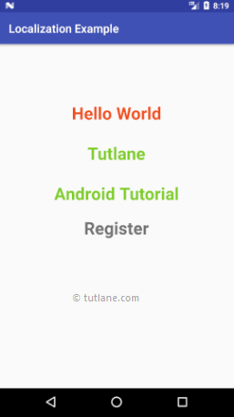

If you observe the above result, by default the app showing in English because the device language is **English**.

Now we will change the device language, for that go to **Settings** à **Language & Input** à Select **Telugu**. Our app will show the details in **Telugu** like as shown below.

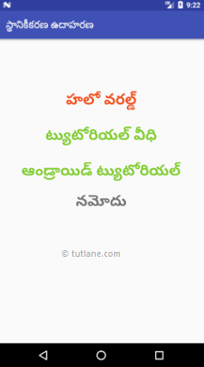

Again change the device language to **Hindi**, our app will show the details in **Hindi** like as shown below.

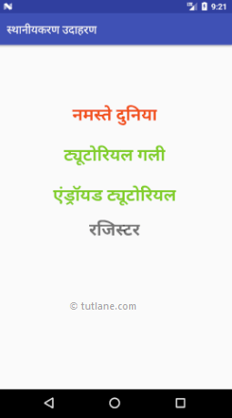

Now we will change the device language to **Japanese**, Our app will show the details in **Japanese** like as shown below.

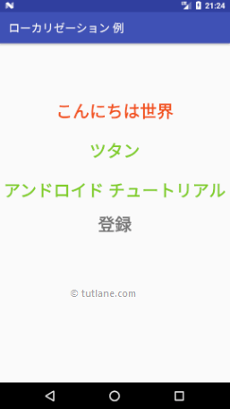

This is how we can implement a multi-language or localization app in android to support multiple languages based on our requirements.